School Travel Plan

Linslade Lower School

Date 2024-2025
School address: | Linslade Lower School  Leopold Road  Linslade  LU7 2QUi
Existing school type: | Lower
Existing number of pupils: | 173
Existing age range of pupils: | 3 to 9 year olds
Existing number of staff: | Full time: 3
Existing number of staff: | Part time: 27
School opening hours: | Site opening/closing times: 7.30am-6.00pm
School opening hours: | Breakfast Club start time (if applicable): 7.30am
School opening hours: | School hours: 8.45am-3.30pm
School opening hours: | Nursery/pre-school hours (if applicable):9.00am- 12.00pm and 12.20pm-3.30pm
School opening hours: | After School Club finish time (if applicable): 6.00pm
School opening hours: | Community usage outside of school hours (if applicable) – are they able to use car park:  Tuesday and Wednesday lettings until 9.00pm
Does the school have a catchment area or operate a ‘nearest school’ policy? | As per CBC Admission Policy
If there is a catchment area or ‘nearest school’ policy, how many of the existing pupils come from outside of the designated area? | As per CBC Admission Policy
Description of the school site, location, and the surrounding road network

Is there more than one entrance to the school for vehicular traffic? If there is more than one, which entrance is used the most?
Is there more than one entrance to the school for pedestrians and cyclists? If there is more than one, which entrance is used the most?
What are the pavements surrounding the school like? Are there dropped kerbs at side road crossings?
Does the main road outside of the school have traffic calming, a School Crossing Patrol, or a controlled crossing such as a Zebra, Toucan or Pelican?
What is the speed limit on the roads surrounding the school?
Is there a cycle route nearby that connects into the school site?
Are there any other schools nearby?
A plan of the area can be included.
Linslade Lower School is situated on a one way street. There is one entrance for cars and three entrances for pedestrians and cyclists. The main entrance for pedestrians and cyclists is on Rock Lane. All children are bought to school and collected by an adult. The majority of families walk to school, with just less than half driving. This causes congestion in the surrounding area in the morning and evening. Parking can be difficult in the streets surrounding school.
The pavements around the school are uneven and prone to flooding. This has been reported to CBC.
There are no traffic calming measures. The speed limit is 20MPH.

Existing Travel Patterns - Pupils
Data should be taken from the most recent ‘Hands Up’ travel survey (completed in September each year). If the data is unavailable, this can be completed at any time (try to choose a day where all pupils are expected to attend school, for example not during the exam period, when some pupils are on a residential trip or where poor weather conditions may affect the figures).

How do pupils usually travel to school for the main part of their journey?
 | 2023 | 2022
Number of pupils present: | 152 | 153
Number of pupils absent: | 8 | 4
Date data collected: | 19-9-23 | Sept 2023
Walk: | 85 | 84
Cycle: | 9 | 6
Scoot/Skate: | 13 | 14
Car: | 42 | 44
Car Share*: | 3 | 4
Park and Stride**: | 0 | 0
School Bus: | 0 | 0
Public Bus: | 0 | 1
Train: | 0 | 0
* Car share is defined as travel in a car with a child or children from another household.
** ‘Park and stride’ is defined as parking in a designated car park and completing the last part of the journey on foot or by scooter.

Compare the data above to that collected in previous years. Has there been an increase or reduction in a particular mode of travel? Is there a known reason for this?
These figures are about the same as previous years.

Existing Travel Patterns - Staff
Data can be taken from the most recent ‘Hands Up’ travel survey (completed in September each year). If the data is unavailable, this can be completed at any time (try to choose a day where all staff who are expected to attend school are present).
How do staff members usually travel to school for the main part of their journey?
Number of staff present: | 27
Number of staff absent (who would usually be expected at school on the day the data was collected): | 1
Date data collected: | Sept 2023
Walk: | 7
Cycle: | 0
Car: | 20
Car Share*: | 0
Park and Stride**: | 0
Public Bus: | 0
Train: | 0
* Car share is defined as travel in a car with someone from another household.
** ‘Park and stride’ is defined as parking in a designated car park and completing the last part of the journey on foot.
Compare the data above to that collected in previous years. Has there been an increase or reduction in a particular mode of travel? Is there a known reason for this? Are there any barriers to increasing the use of sustainable travel?
These figures are about the same as previous years.

Existing parking arrangements

Total number of existing parking spaces within the school site | 15
Number of disabled parking spaces | 2
Number of electric vehicle charging points | 0
Are any of the parking spaces allocated to another specific group such as visitors, parents, students? | No
Are any arrangements in place to allow additional parking at a location outside of the school site? If yes, where is this and how many parking spaces are permitted? Are there any restrictions on when these parking spaces can be used? Is permission in place? | No
On an average day do any staff have to park on the road? If yes, how many? | 0
Are the car parking arrangements managed by a member of staff? If yes, who? | Yes- Hazel Farlam
Are there any bus parking spaces within the school site? If yes, how many?  Are any children transported by school bus? | 0

Existing cycle and scooter parking facilities

Number of cycle parking stands – how many cycles can be parked?  Refer to Parking standards | 1 cycle stand= 20 cycles/scooters
Number of scooter parking facilities at the school | 1 cycle stand= 20 cycles/scooters
Are the cycle/scooter stands covered by a shelter? | Yes
Is the scooter/cycle parking area easily accessible?  Are there any improvements that could be made? | Yes
Does the school have any locker facilities or a safe place where cycle helmets can be stored for both pupils and staff? | No

Are there any sustainable travel initiatives already in place?

For example: Is car sharing promoted? Is there a park and stride location? Have Junior Road Safety Officers been appointed (contact CBC Road Safety team)? Bikeability/scooter training in place? Do the school take part in Walk to School Week/Month, Big Walk and Wheel, or Bike Week?
How are these initiatives publicised to pupils, parents and staff? Newsletters, website, emails, noticeboards?
Many already children scoot or cycle to school. Currently we have one covered cycle/scooter store in main school. This is not enough space to hold all the scooters and cycles on a busy day. We offer cycling proficiency sessions for children in Year 4 ready for their transfer to middle school.
The school have Eco Schools’ Green Flag accreditation. We will investigate the transport module of this.

Review of current travel arrangements

In relation to travel at the start and end of the school day what currently works well?
For example, a high proportion of pupils walk, scoot or cycle, good parking etiquette by those collecting pupils, good compliance with waiting restrictions, School Crossing Patrol or a controlled crossing that is well used etc.
We have a parents waiting area for parents to shelter under when it rains. Mostly parents park respectfully. Most children walk, cycle or scoot to school. There is a controlled crossing on Soulbury Road that leads onto Leopold Road.

In relation to travel at the start and end of the school day what could be improved?
For example, parking that causes congestion, parking on pavements, poor compliance with waiting restrictions, parked vehicles restricting visibility at junctions, narrow pavements, no dropped kerbs at junctions etc. How will parents be informed - newsletters/website/email.
Parents are reminded to park considerately in newsletters and via email.
We would like to encourage more families to cycle or scoot to school. It is important to have somewhere to store the scooters and cycles safely. Educating families about the benefits of walking, cycling or scooting to school should encourage them to drive less frequently. This would reduce congestion around the school and make access easier for the neighbours who sometimes get blocked in.

Aim of the School Travel Plan

Some ideas are as follows:
To understand the existing travel patterns on the journey to and from school.
To increase the number of journeys to and from school using a sustainable mode of travel.
To understand the safest walking and cycling routes to and from school.
Our targets-
- To increase the numbers of children cycling or scooting to and from school by September 2024 when the next travel survey is completed.
- To inform families of the benefits of walking, cycling or scooting to school.
- Decrease the numbers of cars in the local area at drop off and pick up times.

Objectives of the School Travel Plan

The objectives should address the travel improvements identified. Some ideas are as follows (there should be a minimum of 5 objectives):
To reduce the number of cars parked on surrounding roads at the start and end of the school day.
To increase the number of pupils walking and cycling/scooting to school.
To promote the existing bus routes.
To promote park and stride.
To encourage car sharing.
Establish a working group with school, parents, governors, representatives of the local community.
Provide more storage to cycles and scooters on site
Hold a walk, scoot or cycle to school week
Information about the benefits of walking, cycling or scooting to school in the newsletter on a regular basis
To reduce the number of cars parked on surrounding roads at the start and end of the school day.
To increase the number of pupils walking to school.
To promote the existing bus routes (possibly only of use to staff). Plan Your Journey | Traveline
Service 165:
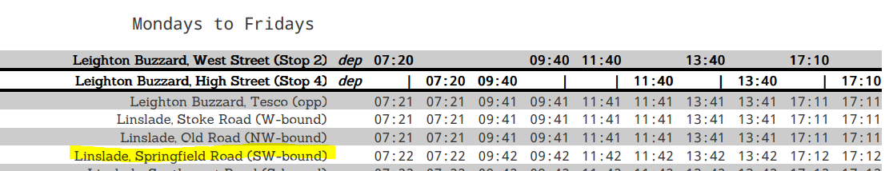
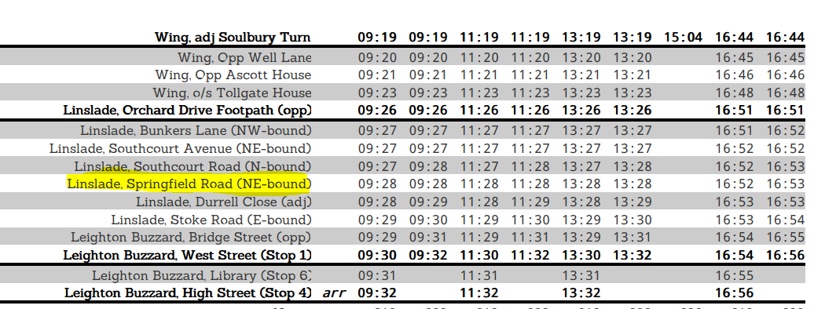
Service X4:
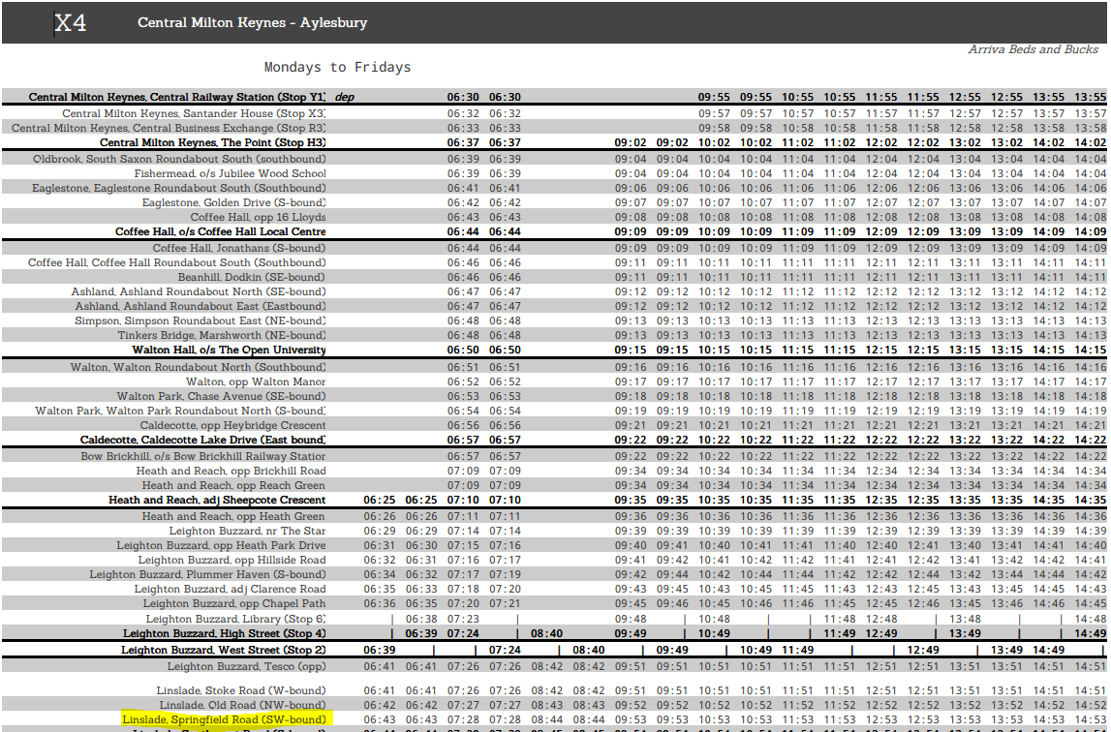
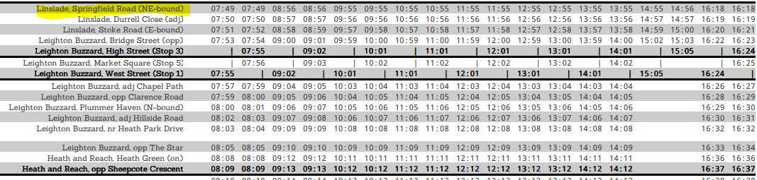
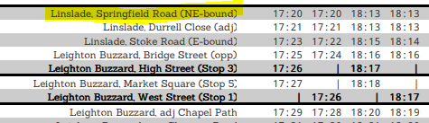

To promote park and stride. Tesco Car Park would be a good base.
To encourage car sharing amongst staff Car share with trusted, reviewed and rated Liftshare.com members.
Establish a working group with school, parents, governors, representatives of the local community.
How will the objectives be achieved?

Some ideas are as follows:
Consider whether additional waiting restrictions may be required.
Prepare a travel information leaflet that is distributed to pupils, parents and staff – to be made available on the school’s website and noticeboards.
Include local bus routes and timetables in the Travel Information Leaflet and Travel Plan.
Set up a park and stride scheme - investigate whether the car park could be used by parents at the start and end of the school day (permission will need to be agreed).
Encourage staff to sign up to Lift Share either between themselves or via https://liftshare.com
Cyclescheme for staff What is the cycle to work benefit? - Cyclescheme
Set up a system to encourage parents to car share informally between themselves.
Set up a Travel Plan working group (to include the school, parents, governors and representatives of the local community).
HF to apply to CBC for funding
HF to write to all families
HF to include information about the benefits of walking, cycling or scooting to school in newsletters on a regular basis
Prepare a travel information leaflet that is distributed to pupils, parents and staff – to be made available on the school’s website and noticeboards.
Include local bus routes and timetables in the Travel Information Leaflet and Travel Plan.
Encourage staff to sign up to Lift Share either between themselves or via https://liftshare.com
Promote park and stride in newsletters. Tesco Car Park would be a good base.
Cyclescheme for staff What is the cycle to work benefit? - Cyclescheme
Set up a Travel Plan working group (to include the school, parents, governors and representatives of the local community).

Action Plan
Each school is required to complete an Action Plan which will include short, medium and long-term initiatives that are intended to be completed/worked towards in order to achieve the aims and objectives.
Some of the proposed actions have been filled in below - we ask that every school completes the first five actions. Further proposed actions should be added and any existing initiatives should be included.
The Action Plan should be reviewed and updated annually.
Proposed Action | Description of the action | Action to be completed by (name) | Proposed completion date
Travel Plan Coordinator | Appoint a Travel Plan Coordinator. Include contact details. | Hazel Farlam | Sept 2023
School Travel Survey | Complete ‘Hands Up’ school travel survey and send to CBC. | Hazel Farlam | September each year
Marketing/ publicity | Complete/update school travel information leaflet.  Consider how the chosen initiatives will be communicated to parents, pupils and staff (newsletter, website, noticeboards, emails). | Hazel Farlam | By September 2024
Provide more storage to cycles and scooters on site | In the spring/summer term HF to apply to CBC for funding | Hazel Farlam | Spring/summer 2024
Hold a walk, scoot or cycle to school week | In the summer term HF to write to all families  Big Walk and Wheel  Walk to School Week | Hazel Farlam | Summer 2024
Information about the benefits of walking, cycling or scooting to school in the newsletter on a regular basis | In the spring/summer term HF to include information about the benefits of walking, cycling or scooting to school in newsletters on a regular basis | Hazel Farlam | Spring/summer 2024
Modeshift STARS | Sign up to Modeshift STARS https://www.modeshiftstars.org/education/  Fill in details of any initiatives that have already been completed (see Modeshift STARS Initiatives Guide). | Hazel Farlam | Spring 2024
Bikeability | Pupils to take part in L2 Bikeability training | Hazel Farlam | Summer 2024
Travel Plan Review | Agree date for annual School Travel Plan review with key stakeholders and CBC. | Hazel Farlam | Annually

School Travel Plan Approval

School Travel Plan Co-ordinator: | Signature: | 
School Travel Plan Co-ordinator: | Print name: | Hazel Farlam
School Travel Plan Co-ordinator: | Job title: | Headteacher
School Travel Plan Co-ordinator: | Email: | hfarlam@linsladelower.beds.scu.uk
School Travel Plan Co-ordinator: | Telephone: | 01525 372085
School Travel Plan Co-ordinator: | Date: | February 2024

Head Teacher: | Signature:
Head Teacher: | Print name: | Hazel Farlam
Head Teacher: | Email: | hfarlam@linsladelower.beds.scu.uk
Head Teacher: | Telephone: | 01525 372085
Head Teacher: | Date: | February 2024

Chair of Governors: | Signature: | Mat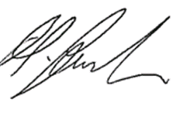
Chair of Governors: | Print name: | Matt Foulis
Chair of Governors: | Email: | mfoulis@linsladelower.beds.scu.uk
Chair of Governors: | Telephone: | 01525 372085
Chair of Governors: | Date: | Feb 2024

School Travel Plan Notes
- We ask that every school has an active School Travel Plan which is updated annually as a minimum.
- The school should appoint a named Travel Plan Coordinator who will be responsible for the overall management of the School Travel Plan and be a main point of contact at the school for any travel and transport related enquiries.
- This template has been put together to assist each school in completing their School Travel Plan. This template doesn’t have to be used; it is recommended that if a different format is adopted that the content is cross referenced with this template to ensure that everything that we ask for is included.
- A working group involving the school, parents, School Council, Governors and representatives of the local community should be established. The group should meet regularly to discuss any issues and implement changes in encouraging sustainable travel.
- To accompany the School Travel Plan we ask that a travel information leaflet is prepared - to include relevant walking and cycling maps, public transport and car sharing information. The travel information leaflet should be communicated to parents/pupils/ staff and made available on the school website/school noticeboard.
- Once completed, an electronic copy of both the School Travel Plan and Travel Information Leaflet should be sent to TravelChoices TravelChoices@centralbedfordshire.gov.uk

Sustainable Travel Initiatives
More information about the initiatives below and other sustainable travel suggestions can be found in Central Bedfordshire Council’s Sustainable Modes of Travel to Schools Strategy available at www.centralbedfordshire.gov.uk.

Modeshift STARS | https://modeshiftstars.org/
Bikeability | https://bikeability.org.uk/
Junior Road Safety Officer | Further information can be found on the Central Bedfordshire Council website including a JRSO Pack and Teacher’s Pack – www.centralbedfordshire.gov.uk
Lift Share | https://liftshare.com



