Linslade Lower School
Homework Bulletin
Mulberry Class
Year 2
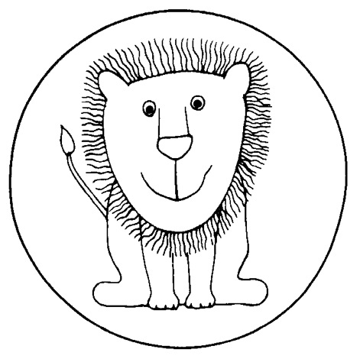

Friday 25th September 2026

This information provides a broad overview of what is being learnt in English and Maths. Teachers adapt lessons to meet the needs of individual pupils.

This week we have been learning:

Maths | - To split numbers in different ways  - To make and complete number patterns  - To be able to know the place value of numbers to 100
English – writing | - To write a list of toppings for a pizza design  - To write simple sentences using capital letters and full stops
English – phonics and spelling | We have been recapping phase 5 graphemes:  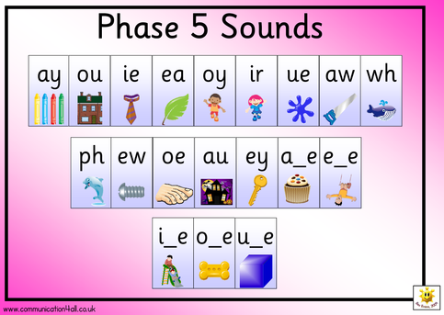  We have also learnt to use the silent /w/ sound as in write, two, sword.

For homework this week:

Maths | Some of the children have found it difficult to count on accurately from any number this week. Please help your child to recognise number patterns/sequences. E.g.  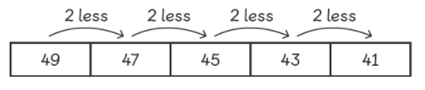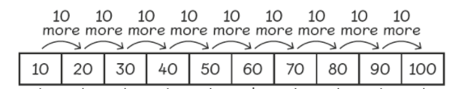  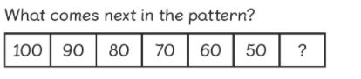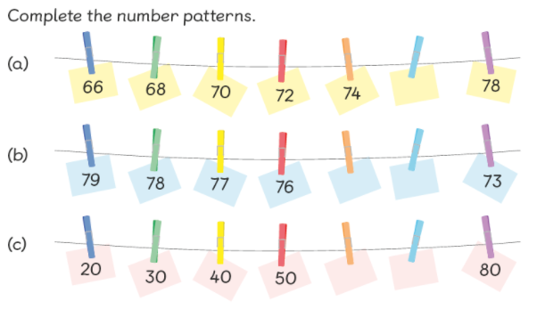  You could make up some more patterns for your child, counting on or back in steps of 2, 5, 10 or 3. If your child needs more challenge, make their sequences more complex by counting backwards or giving them different number of steps to count in (i.e. in 4s).  This is a nice game to practice counting in steps of 2, 5, 10 (and 3 if confident on the other multiples) https://ictgames.com/mobilePage/duckShoot/index.html

English reading | Please hear your child read their home reading book for around 10 minutes per day and complete the reading record. Please aim to read 3 or more times a week.
Phonics and spelling | Silent <w>  - chat  - cash  - write  - wrist  - wreck  - wrong  - answer  - swordfish  - sister  - brother  Every week your child will be given ten spelling words. Please help them to learn them. The first two spelling words are “regular”. This means they can be spelled out by listening for the sounds and writing the letters for them. The next six words use the spelling pattern of the week. The last two words are usually common exception, or “tricky” words and have to be learned by practising as they have no regular spelling pattern. Please see the list below. We will check your child’s spelling next Thursday.

